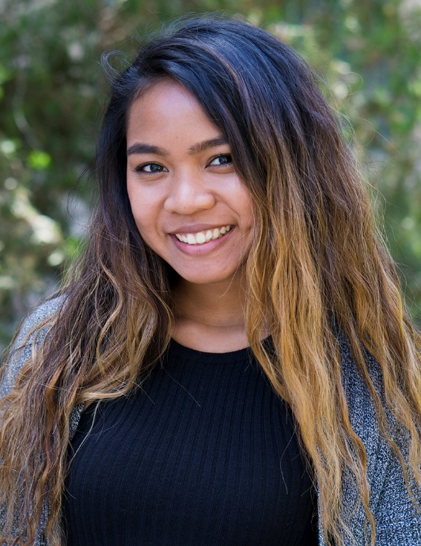

Ashley Fabillaran
Winter 2018

Admin Support Employee
of the Quarter
Admin

 | Emily Hurry  Fall 2017 |  | Nur Sattar  Spring 2017 | 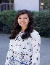 | Juliana Lamera  Winter 2017
 | Cat Castillo  Fall 2016 |  | Teresa Datar  Spring 2016 |  | Fatima Barron  Winter 2016
 | Alexis Caligiuri  Fall 2015 |  | Thao Nguyen  Spring 2015 |  | Teresa Leon  Winter 2015

Computer Lab Management
IET-Academic Technology Services

